NPR - Take The ACE Quiz — And Learn What It Does And Doesn't Mean
March 2, 2015
Laura Starecheski
An ACE score is a tally of different types of abuse, neglect, and other hallmarks of a rough childhood. According to the Adverse Childhood Experiences study, the rougher your childhood, the higher your score is likely to be and the higher your risk for later health problems. You can take the test below:
So, you've got your score. Now what?
First, remember that the ACE score isn't a crystal ball; it's just meant as guidance. It tells you about one type of risk factor among many. It doesn't directly take into account your diet or genes, or whether you smoke or drink excessively — to name just a few of the other major influences on health.

To learn more, check the CDC's ACE Study website. You'll find, among other things, a list of studies that explore the ways adverse childhood experiences have been linked to a variety of adult conditions, ranging from increased headaches to depression to heart disease.
Remember this, too: ACE scores don't tally the positive experiences in early life that can help build resilience and protect a child from the effects of trauma. Having a grandparent who loves you, a teacher who understands and believes in you, or a trusted friend you can confide in may mitigate the long-term effects of early trauma, psychologists say.
"There are people with high ACE scores who do remarkably well," says Jack Shonkoff, a pediatrician and director of the Center on the Developing Child at Harvard University.
Resilience, he says, builds throughout life, and close relationships are key. Recent research also suggests that for adults, "trauma informed" therapy — which can center on art, yoga or mindfulness training — can help.

Three Types of ACEs
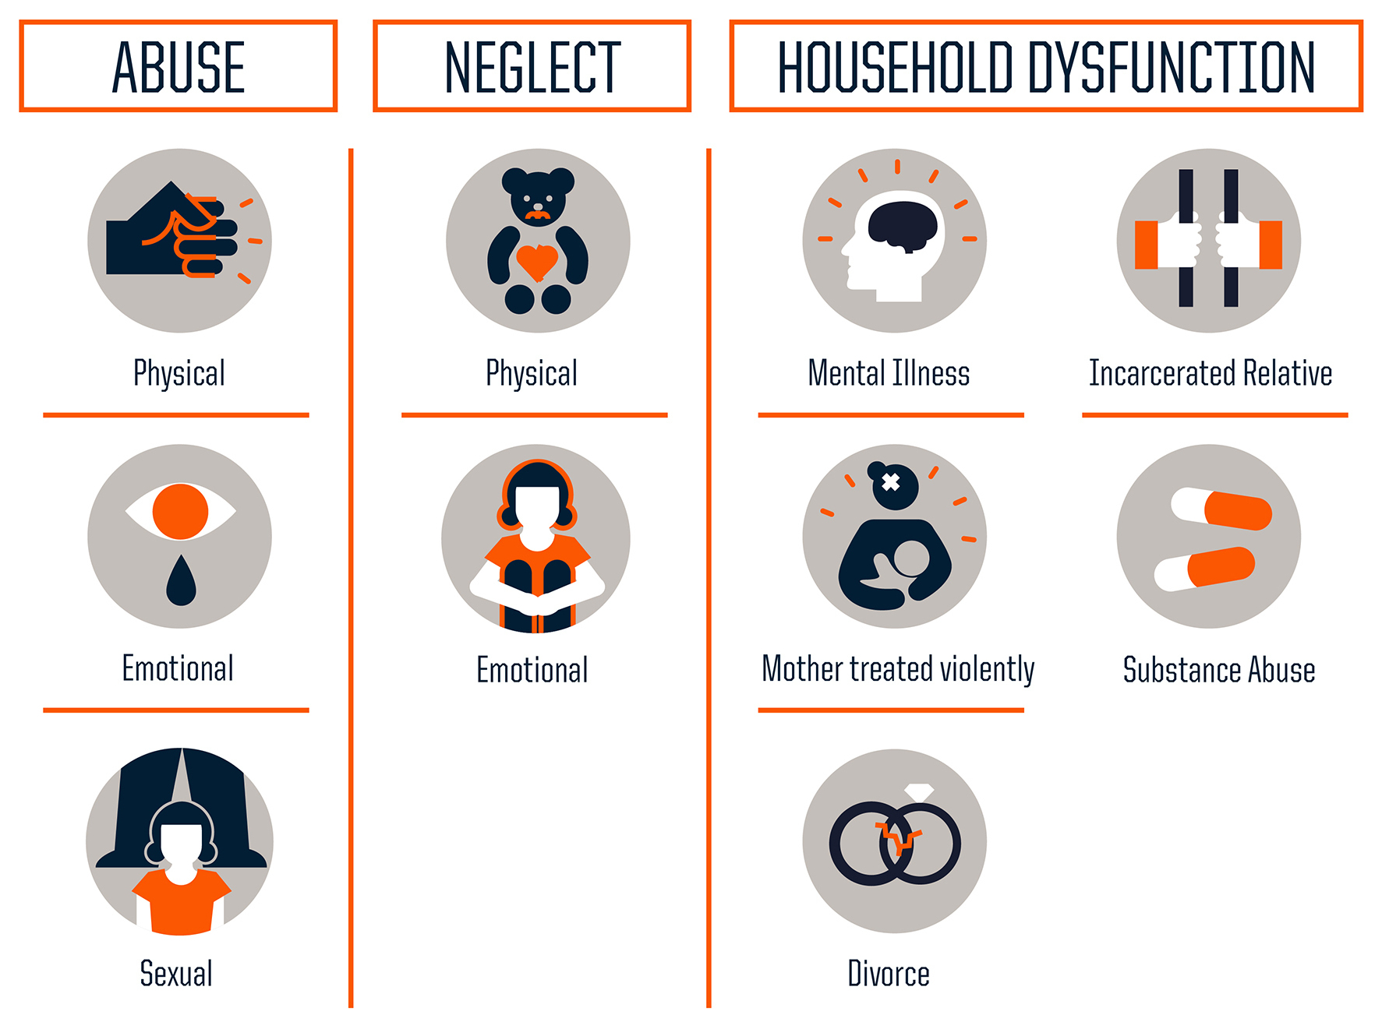
Source: Centers for Disease Control and Prevention
Credit: Robert Wood Johnson Foundation
How best to find and help kids who are experiencing abuse and neglect right now?
Child psychologist Hilit Kletter, of Stanford University's School of Medicine, says that to spot these children, she looks for visible signs of stress to understand what might have happened to them and how best to intervene. Some kids have nightmares or recurring thoughts of a stressful event, she says, or may re-enact the trauma through play. Or the child may seem distracted or withdrawn.
"This will come out at school," Kletter says. "Teachers will tell parents [their child] seems to be in a daze in the classroom, not paying attention."

ACEs Increase Health Risks
According to the Adverse Childhood Experiences study, the rougher your childhood, the higher your score is likely to be and the higher your risk for various health problems later.
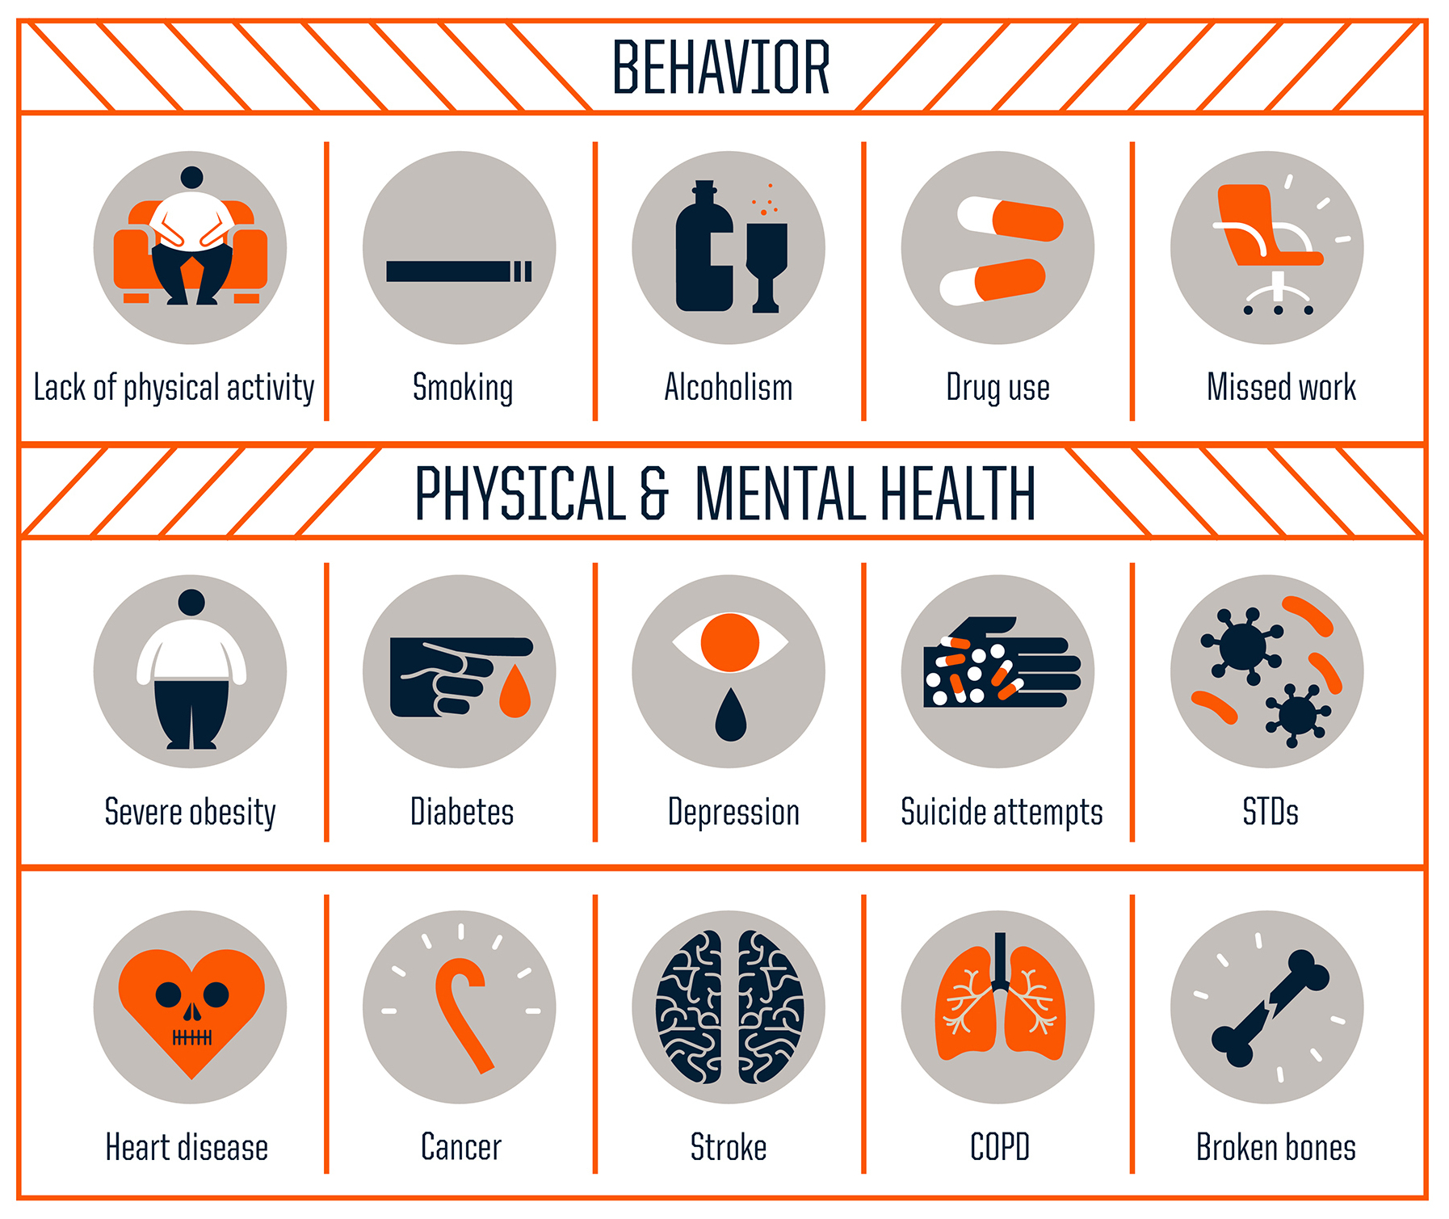
Source: Centers for Disease Control and Prevention
Credit: Robert Wood Johnson Foundation
Kletter says reactions to trauma are sometimes misdiagnosed as symptoms of attention deficit hyperactivity disorder, because kids dealing with adverse experiences may be impulsive — acting out with anger or other strong emotions.
"It's something that's very common in trauma: difficulty in regulating emotions and behavior," she explains. "That's why a lot of these kids get in trouble with the classroom."
Shonkoff's research center at Harvard tests interventions that can build resilience in kids who are growing up with adverse experiences — not just problems in the family, such as those the ACE study investigated, but also trauma stemming from poverty, for example, or from the chronic stress of racial or gender discrimination.
To bolster parents, the Harvard team is testing interventions right now that use video coaching to show moms and dads how to engage their babbling infants, using sounds and facial expressions in a style Shonkoff calls serve and return.
Shonkoff says these early interactions — a kind of conversation — have been shown to help children with later learning and literacy. Even more important, they boost kids' resilience, by helping them build secure attachments with caring adults. Research suggests that just one caring, safe relationship early in life gives any child a much better shot at growing up healthy.

